Kidambi Srikanth becomes first Indian male player to clinch Swiss Open
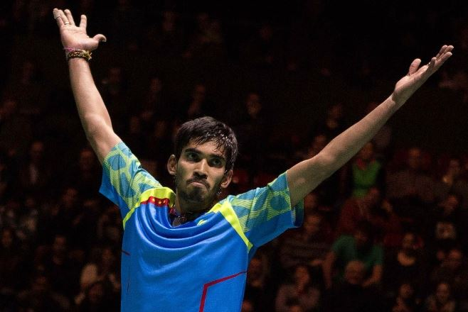
BASEL: Putting his All England Open disappointment behind, top Indian shuttler Kidambi Srikanth displayed pure class to oust defending Champion Viktor Axelsen and clinch the Men's Singles title at the USD 120,000 Swiss Open Grand Prix Gold on Sunday.
In the final at St. Jakobshalle, the top seed defeated the Dane 21-15, 12-21, 21-14 in 47 minutes in their first career meeting. This is the first time an Indian male has won the title after compatriot Saina Nehwal clinched back-to-back Women's Singles crowns in 2011 and 2012.
The World No.6 Axelsen gave a tough fight to the 22-year-old Indian at the start as he matched shots to stay level till 8-all. However, Srikanth upped the ante to start extending the lead and reached 20-13 in no time. The second seed managed to save two game points before Srikanth sealed it on the third.
Axelsen, however, turned the tables in the second game. Not once did he allow the World No.4 to dominate and, using his height to good effect, hit several smashes to go into an 11-3 lead. It was too difficult for the Hyderabadi to recover from there and from 16-12, Axelsen won five straight points to win the game and level the match at one-game-all.
The Dane took the momentum into the decider with an important 4-1 lead but the top seeded Indian was not going to give up that easy. Srikanth suddenly found legs to win the next six points and go into a 7-4 lead. It was neck-and-neck between the two shuttlers as neither was ready to give away even a single point, extending the rallies which tired out the Dane. From 13-all, Axelsen only managed to win one of the next nine points as Srikanth displayed top skill to win the game and earn his second Grand Prix Gold title.
“We’re two different eras, hence two varied styles. Yes, he likes to be aggressive and quick like me and we both like dominating the net, so those are the similarities. But he has far more variations when lifting shuttle from below the knees,” Gopichand says.
“Srikanth has these net taps that are unlike most players. He manages to stop opponents from lifting, they’re an awkward length,” he says. What makes him different is how his smashes push back his opponents, pinning them behind the midcourt. Then there’s the big jumping smash which he actually uses as a set-up for his wristy touch play. Smooth in moving to the net immediately after the big booming projectile, Srikanth can anticipate returns and begin his wand-work at the net in one unruffled motion.
His backhand is a mine of immense possibilities and angles, and his finishing stroke is something Indians can be proud of, flaunting it as world-class. “In recent tournaments, he’s gotten more consistent as well. In close matches even if he’s down, he can change his game at will and stage comebacks from the verge of losing,” observes coach Vimal Kumar. “He’s pulling out matches that you’d think he won’t win. Right now, Jan Jorgensen and Srikanth are at the same level, with only Chen Long a shade better than both,” Vimal adds.
At the moment though, it is Srikanth’s unconventional strokes that can delight Indians and pull the crowds at the home Super Series in Delhi starting March 24.
India could be looking at its first No. 1 material here. “He can of course get stronger and develop technically. And with Rio qualification, the big rush for points will start this year. But the best thing right now is that he’s No. 4 at 22.
----------------------------

